**Exercise- Basics of HTML**

**Student Name: Ravi Dawar Student Id: Rxd173330**

**Date: 4/6/2018**

**Step 4.2: Display the HTML document on browser**

**Question:**

1. **Paste the screen shot of your webpage.**

**Answer:**

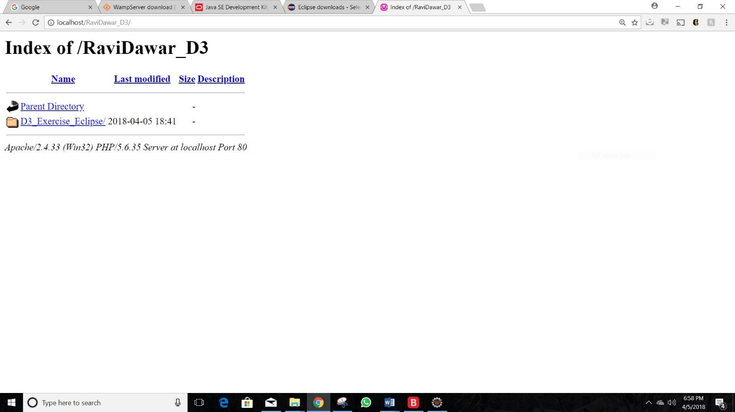

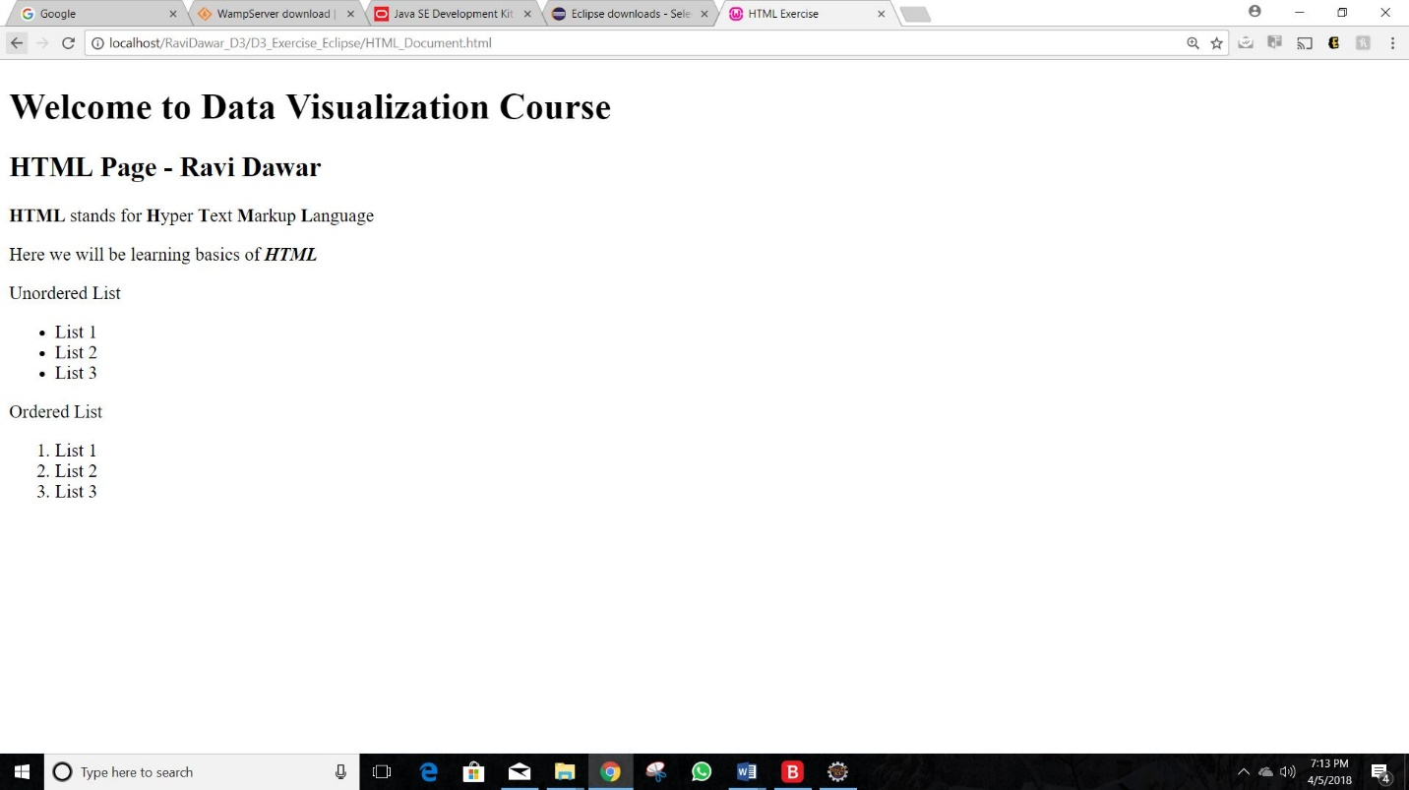

**Step 5.3: Display the HTML document on web browser.**

1. **Paste the screen shot of the HTML_CSS_Link.html document after opening it on the web browser.**

**Answer:**

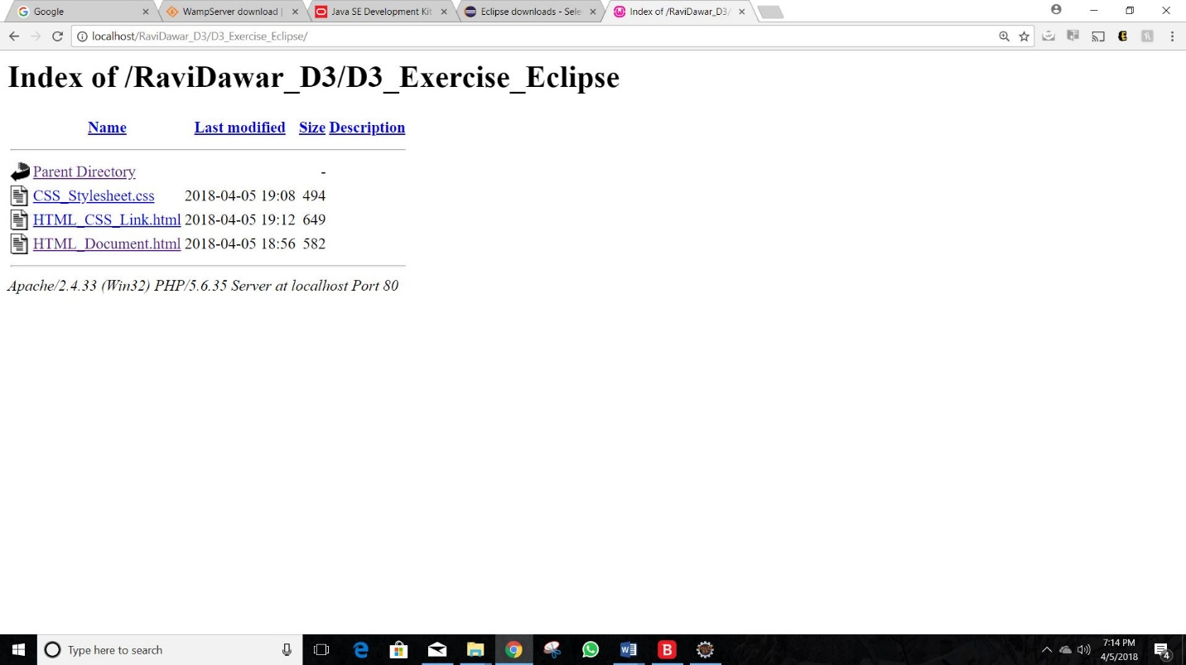

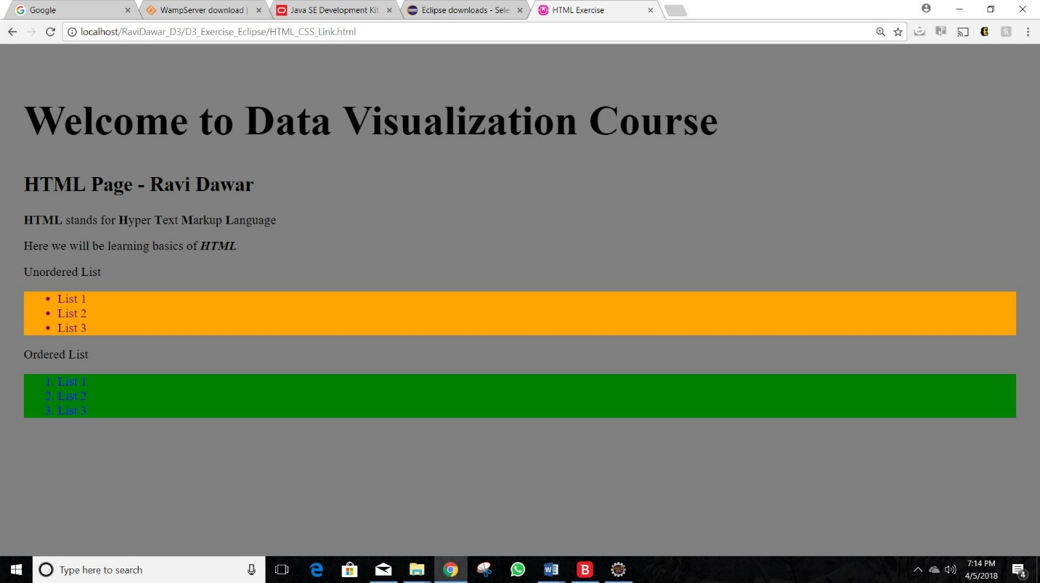

**Step 6.2: Display the HTML document on web browser.**

1. Paste the screen of your **HTML_SVG_Included.html** webpage**.**

**Answer:**

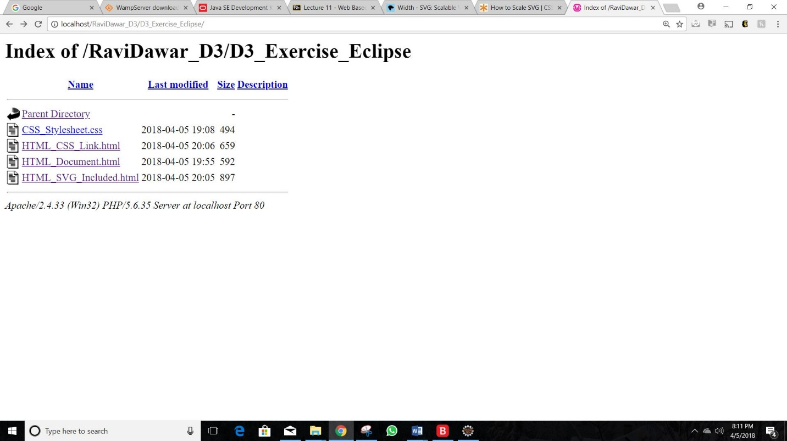

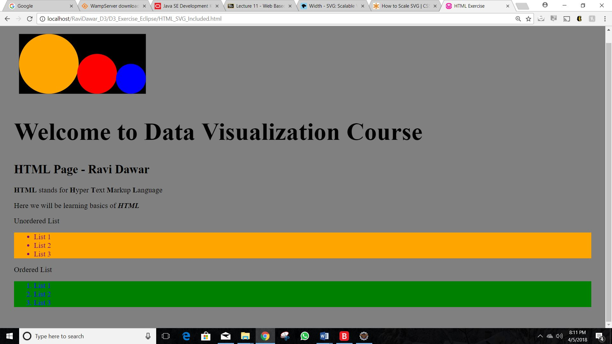

**Step 7.3: Display the HTML document on web browser.**

1. **Paste the screen shot of the Javascript.js document after opening it on the web browser.**

**Answer:**

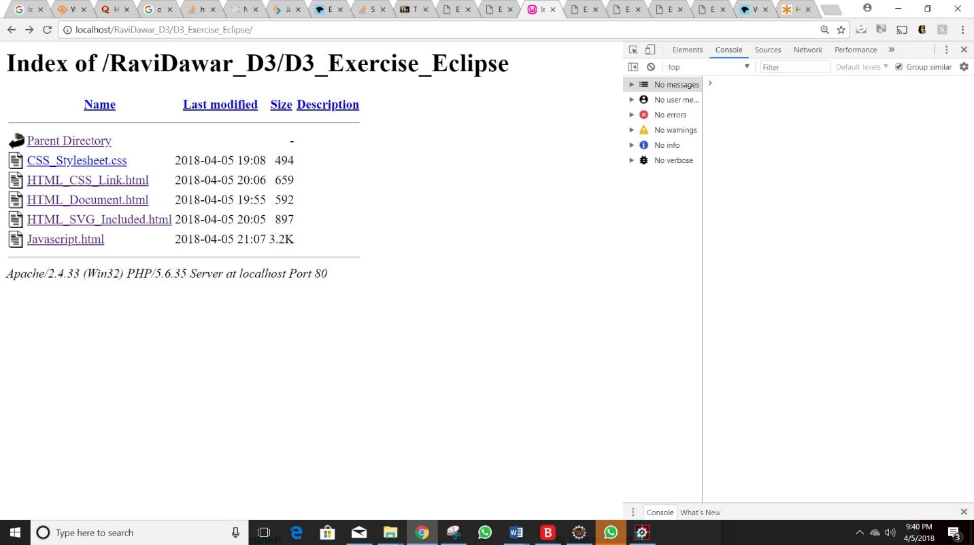

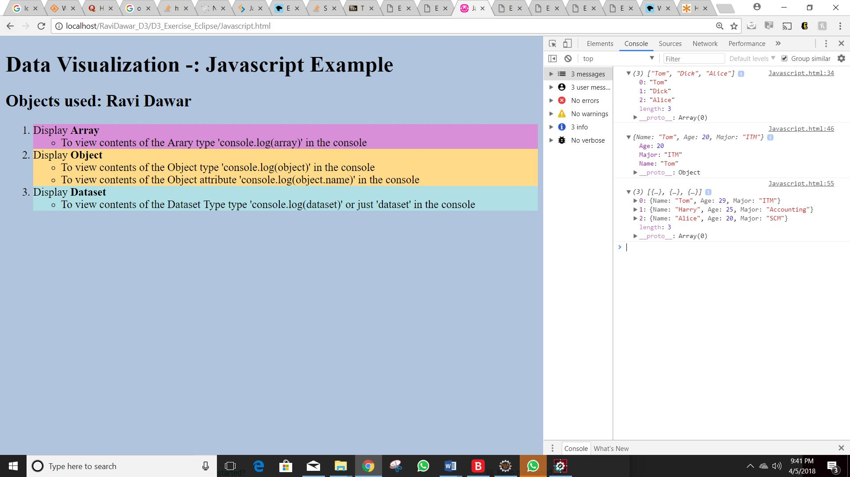

**Step 8.2: Display the HTML document on web browser.**

1. **Paste the screen shot of the LOAD_CSV.html document after opening it on the web browser also display the console log with the array (expand the array) created after loading the data.**

**Answer:**

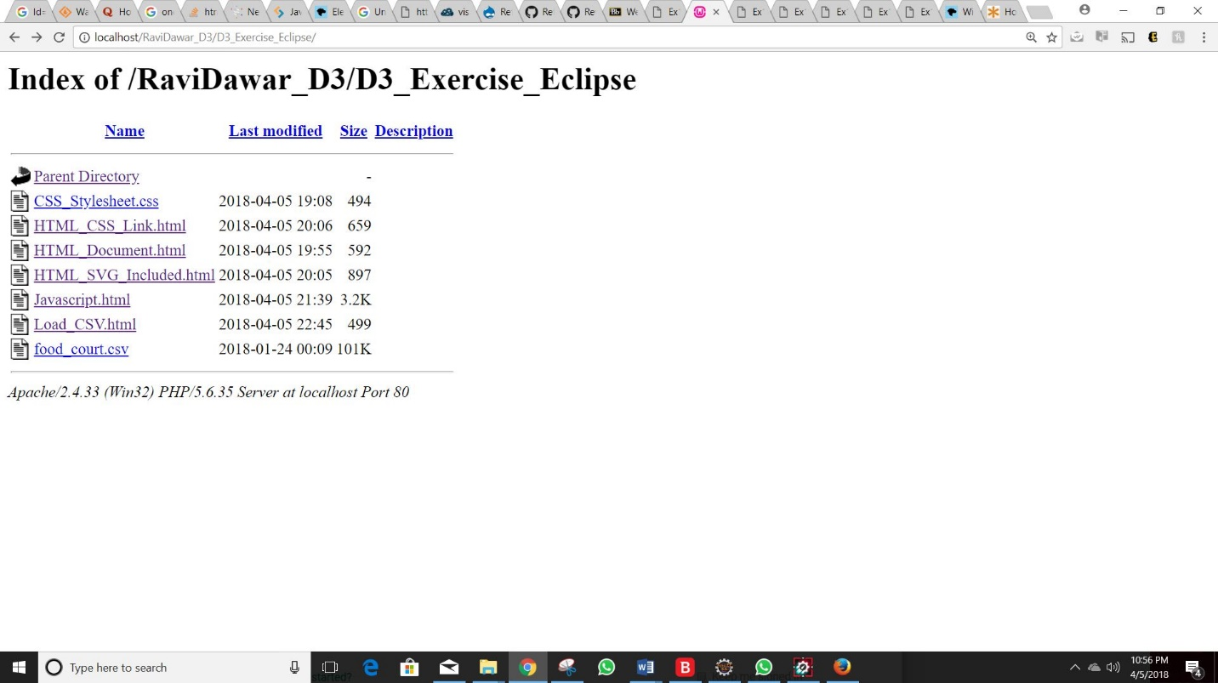

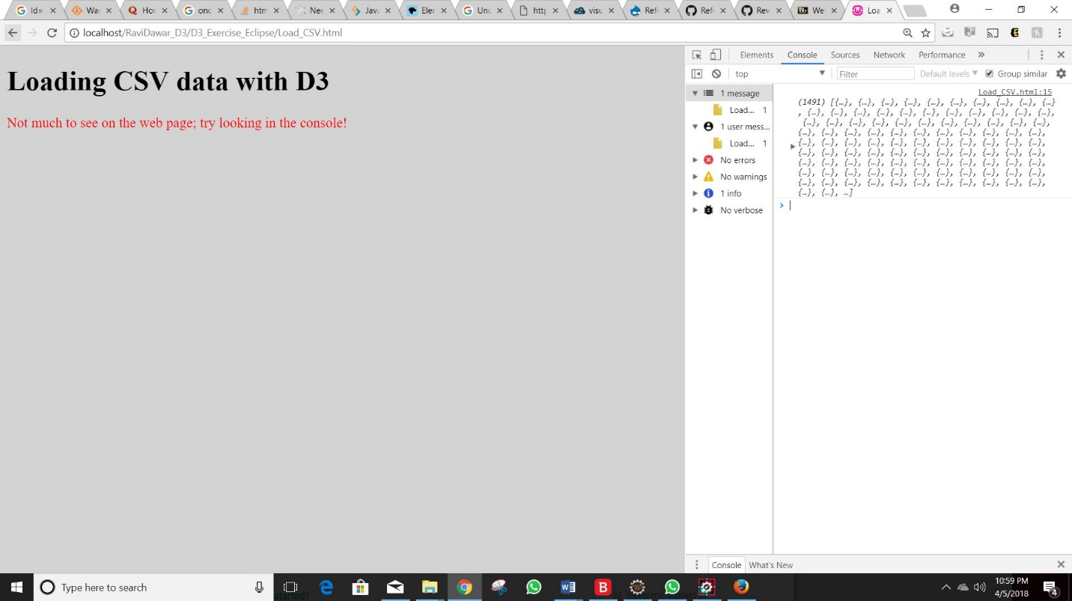

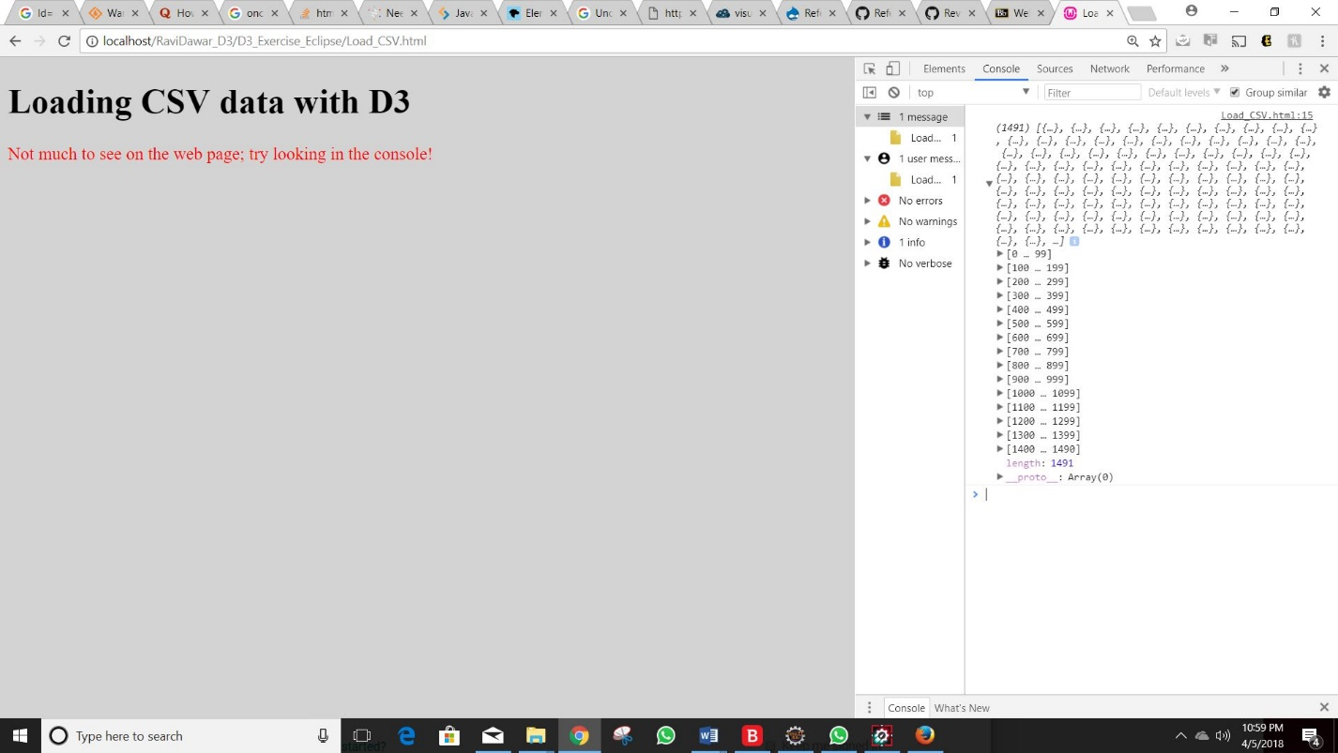

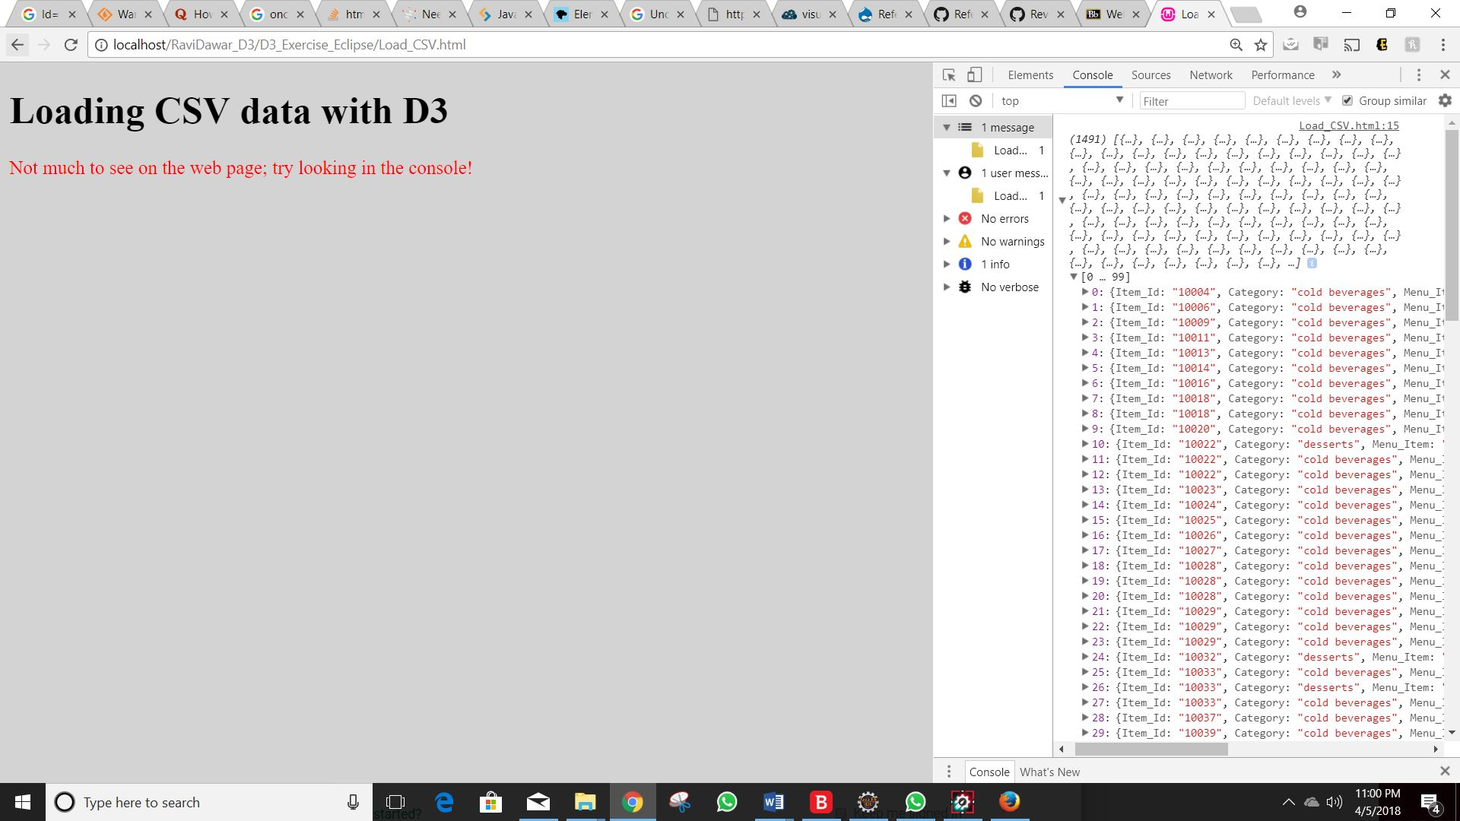

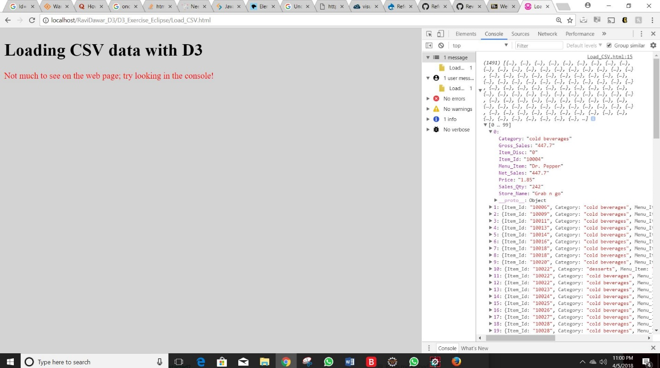

**Step 9: Upload your file in the Gitshub**

1. **What are the 2 types of files you loaded into gist.github.com (hint: refer to step 8 for the details)?**

**Answer: Two types of file loaded in gist.github.com are:**

1. **Food_court.csv (Comma Separated Values)**
2. **index.html (Hyper Text Markup Language)**
3. **What should be the name of the html file while uploading your file in the gist.github.com?**

**Answer: The name of the file should be index.html (all alpha in Lower case), while uploading file in the gist.github.com.**

1. **Paste the screen shot your browser with URL, after creating a public gist.**

**Answer:**

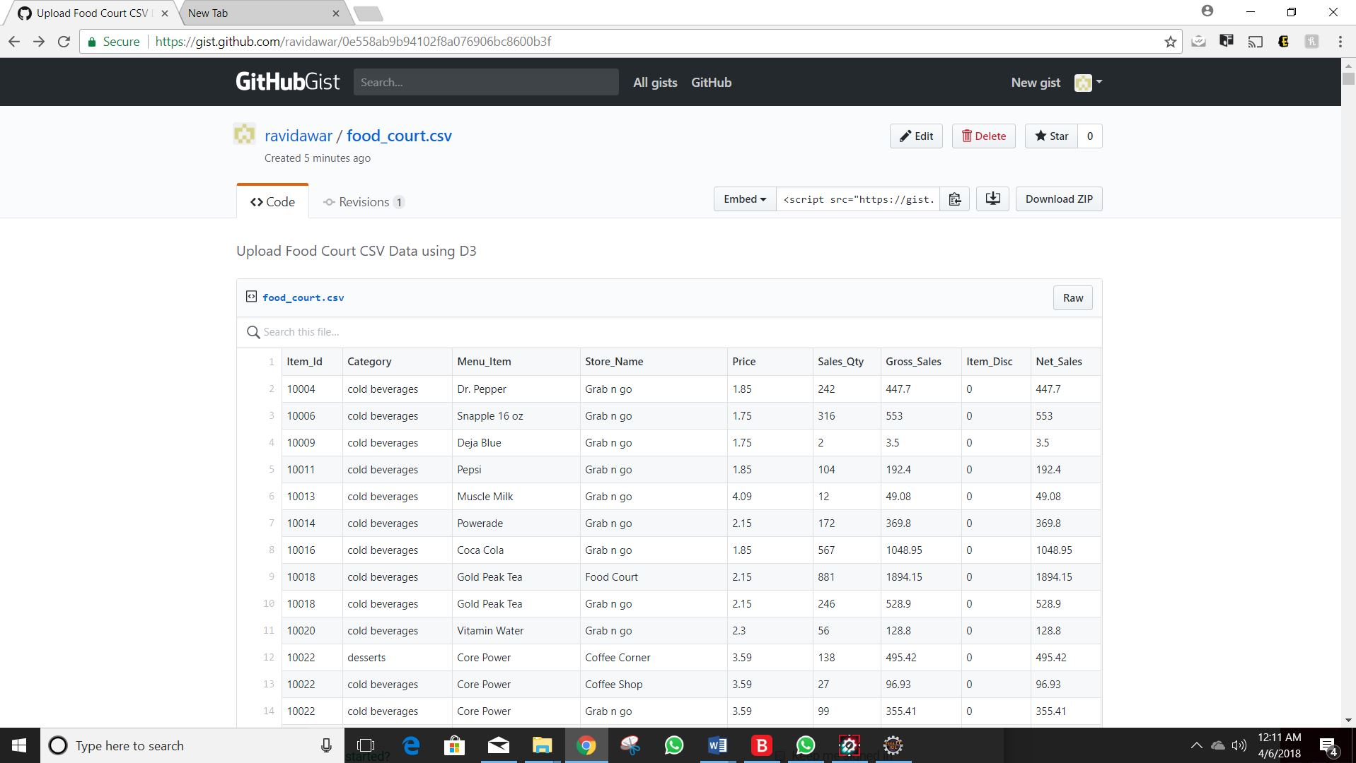

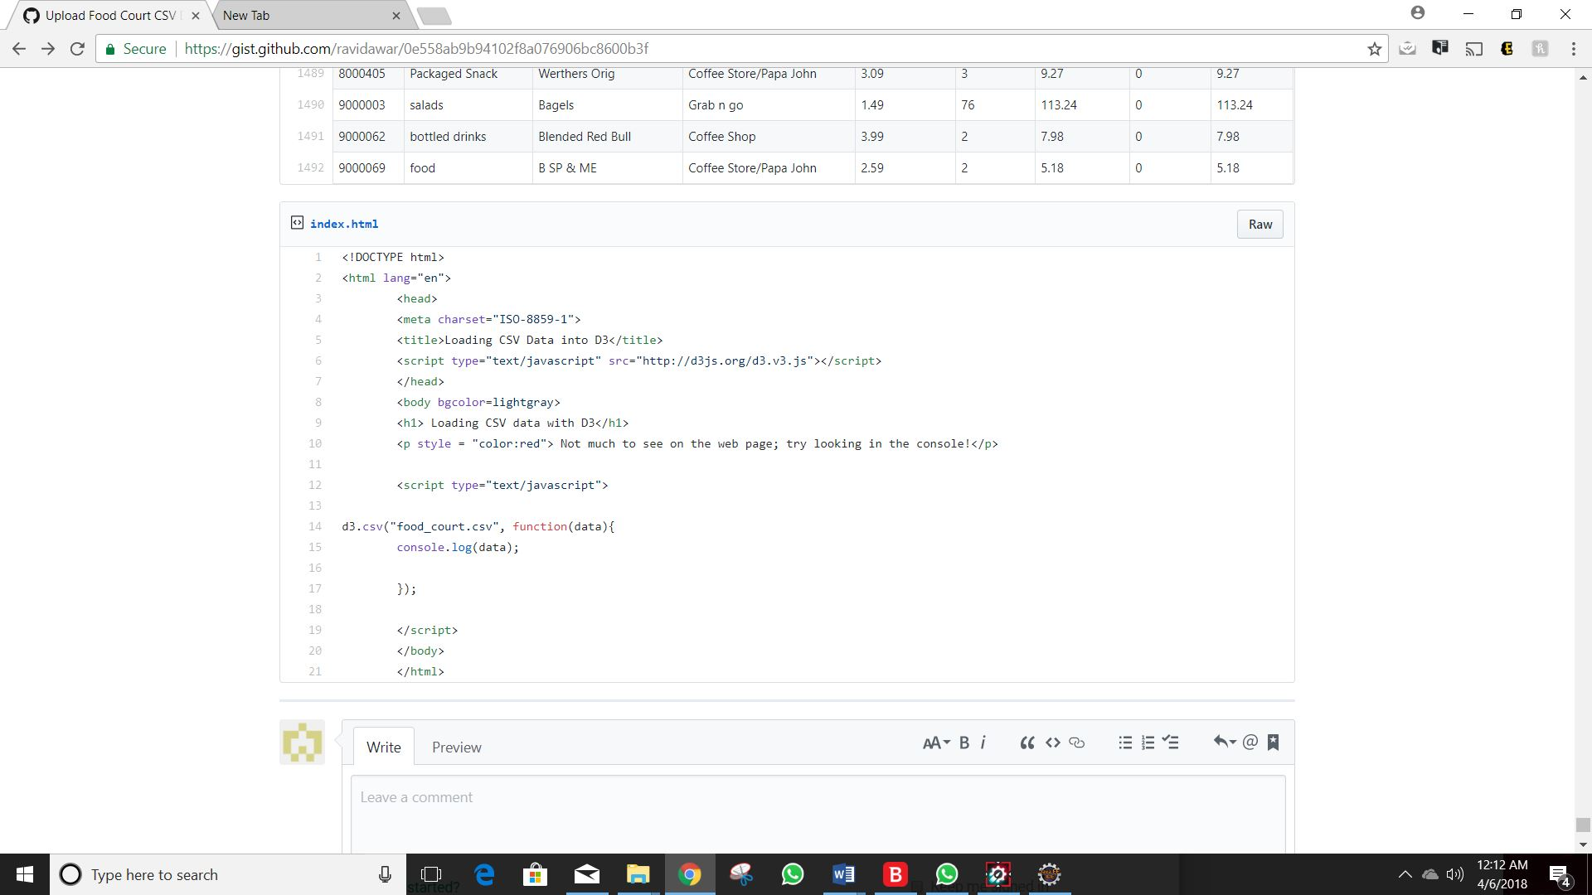

1. **Paste the screen shot your browser after opening your webpage using bl.ocks.org.**

**Answer:**

